** **

**TECHNICAL PROJECT REPORT**

**TITLE OF THE PROJECT – DIGITAL LOCK**

**NAME OF INVENTORS/MEMBERS:**

|  |  |  |  |  |  |  |
| --- | --- | --- | --- | --- | --- | --- |
| **S.No.** | **Name** | **Dept.** | **Designation** | | **Mobile** | **E-Mail** |
| 1. | Himanshu Kunchal | AI&ML-2 | STUDENT | 9541849395 | | [himanshukunchal474700@gmail.com](mailto:himanshukunchal474700@gmail.com) |
| 2. | Ayush Mudgal | AI&ML-2 | STUDENT | 8447718925 | | amudgal2000@gmail.com |
| 3. | Shubham Karnwal | AI&ML-2 | STUDENT | 6395624199 | | skarn2510@gmail.com |
| 4. | Kushal Thakur | ECE | Mentor | 9646030764 | | [kushal.thakur@cumail.in](mailto:kushal.thakur@cumail.in) |
| 5. | Anshul Sharma | ECE | Mentor | 9478697475 | | [anshulsharma.ece@cumail.in](mailto:anshulsharma.ece@cumail.in) |
| 6. | Kiranjot Singh | ECE | Mentor | 9463909689 | | [kiranjotsingh.ece@cumail.in](mailto:kiranjotsingh.ece@cumail.in) |
| 7. | Divneet Singh Kapoor | ECE | Mentor | 9878422653 | | [divneet.ece@cumail.in](mailto:divneet.ece@cumail.in) |

**Section 1(IPR Related)**

**Brief Abstract:**

This project helps in better safety on one’s belongings. One can put his belongings in an Almirah or safe and then lock or unlock it at his own choice. There is no influence of any other control. This helps in better protection of the expensive things. This is primarily based on digital technology.

We have phone and then created an app. We will give input using application via Bluetooth. The signals transmitted by phone are detected by Bluetooth connected to arduino. Bluetooth then transfers the signals to the arduino which detects the value and gives command to the servomotor to rotate. And finally servomotor rotates. It will help to open or close the door.

There can be a number of significance modifications to this project. Some basic modifications one can think of is that we can add face detection, fingerprint detection etc. or we can add alarm also. By adding alarm we mean that whenever a wrong code is added in the app then alarm will start ringing.

**EXISTING STATE OF THE ART AND DRAWBACKS IN EXISTING STATE OF THE ART**

|  |  |  |
| --- | --- | --- |
| **S.No.** | **Existing state of Art** | **Drawback in existing state of Art** |
| 1. | **Physical hinge with no lock**  **Link:**  https://www.amazon.in/Spider-Aldrop-Antique-Finish-A12510MAB/dp/B07DN9597K/ref=sr_1_4?s=kitchen&ie=UTF8&qid=1542545863&sr=1-4&keywords=kundi+lock | It can be easily opened. |
| 2. | **Bluetooth proximity lock**  **Link:**  https://www.instructables.com/id/Bluetooth-Proximity-PC-Lock/ | Can be opened if the robbers gains access of the key. |
| 3. | **Heavy Locks**  **Link:**  https://www.ebay.com/p/Heavy-Duty-Padlock-chain-Lock-94mm-Container-Garage-Warehouse/1575989943?iid=182158566400 | It is a burden to keep the key safe. |
| 4. | **Combination Lock**  **Link:**  https://www.decathlon.in/p/8333020_combination-padlock-blue.html?gclid=EAIaIQobChMIwp3l1P7d3gIVSomPCh01LAS0EAQYBSABEgL0-PD_BwE#/3-254-_ | The owner might forget the lock combination.  Eventually the robber can try out different combinations. |

**ADDITIONAL/NOVEL MODIFICATION THAT YOU CAN PROPOSE TO IMPROVE UPON DRAWBACKS**

1. We can modify it using high sensing technology to detect if lock is open or closed.

2. We can include features like fingerprint detection and face detection.

3. We can make app which allows the user to set and change the Bluetooth password .

**FEATURES & ADVANTAGES OF DIGITAL LOCK**

1. Small in size.
2. Easily transportable.
3. Economical.
4. Easily available.
5. High protection.
6. Keyless entry.
7. Flexible installation.

** BEEE LAB **

**BLOCK DIAGRAM**

MOBILE PHONE

BLUETOOTH

CONTROLLER

SERVO MOTOR

LOCK

**SECTION 2(REAL PROJECT)**

**MATERIAL REQUIRED-**

|  |  |  |  |
| --- | --- | --- | --- |
| **S No** | **Material** | **Quantity** | **Price** |
| 1 | Arduino UNO | 1 | 470 |
| 2 | Micro-Servo Motor | 1 | 200 |
| 3 | Bluetooth HC-05 | 1 | 300 |
| 4 | Lock | 1 | 150 |
| 5 | Arduino USB Cable | 1 | 50 |
| 6 | Jumper Wires | 7 | 30 |
| 7 | Charger Head | 1 | 670 |

**CIRCUIT DIAGRAM**

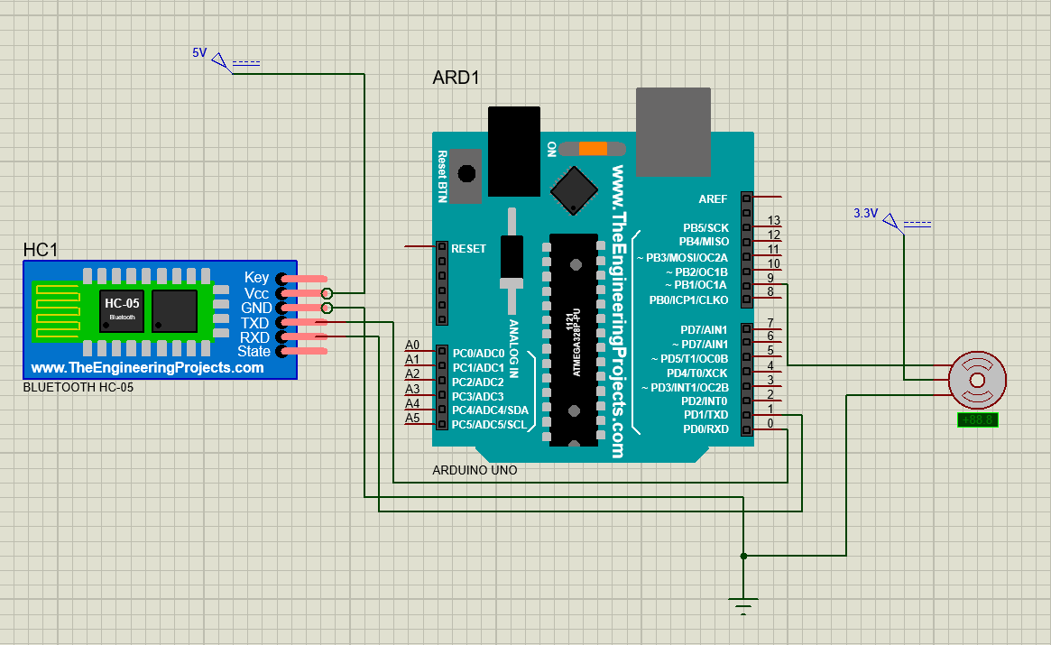

**STEPS OF CIRCUIT COMPLETION**

1. Connect the servo motor to arduino with 3 volt, ground and 9 volt pin.
2. Connect the RX pin of the arduino with the TX pin of the Bluetooth and vice versa.
3. Connect the 5 volt pin of Bluetooth with 5 volt of the arduino and Gnd with the Gnd of the arduino.
4. Connect the arduino to the power supply.
5. Now install the application in your mobile phone which connect with Bluetooth and helps to rotate the servo motor.

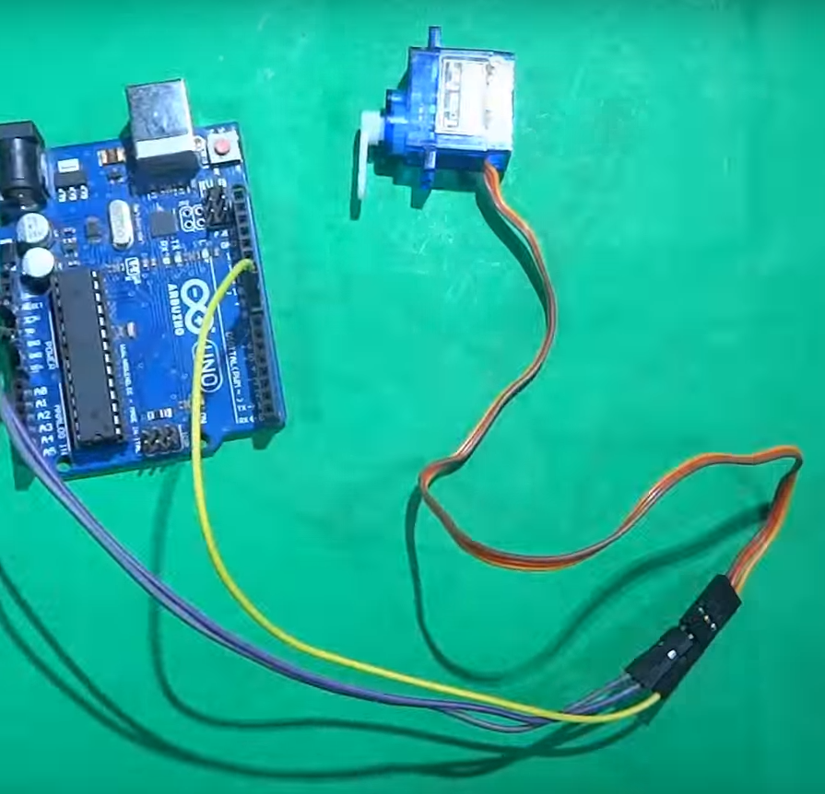

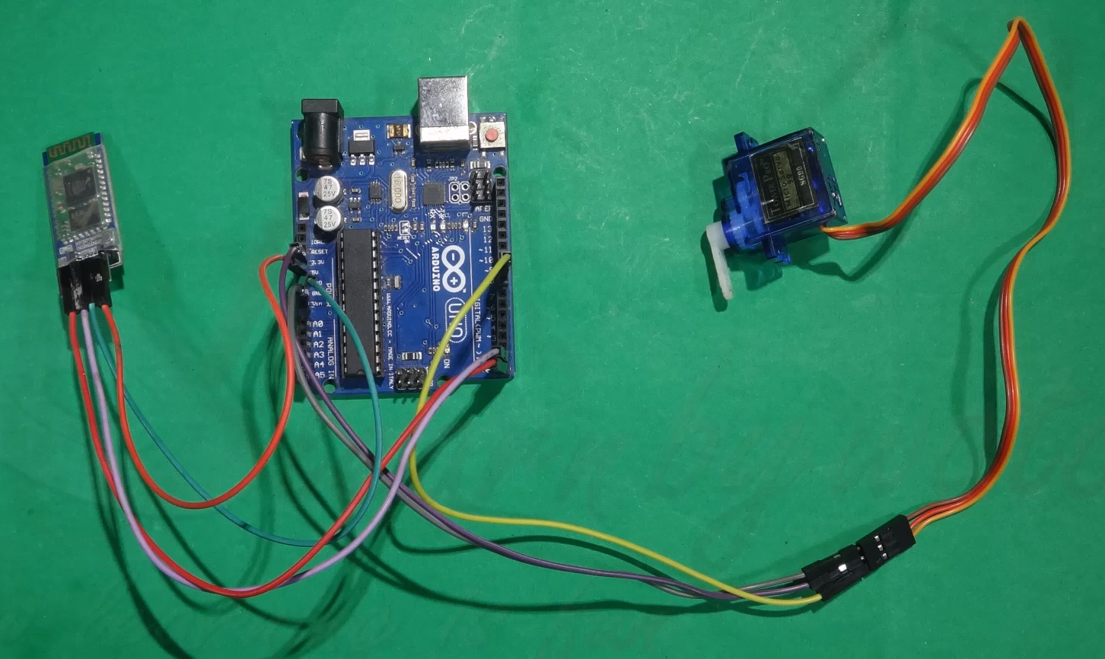

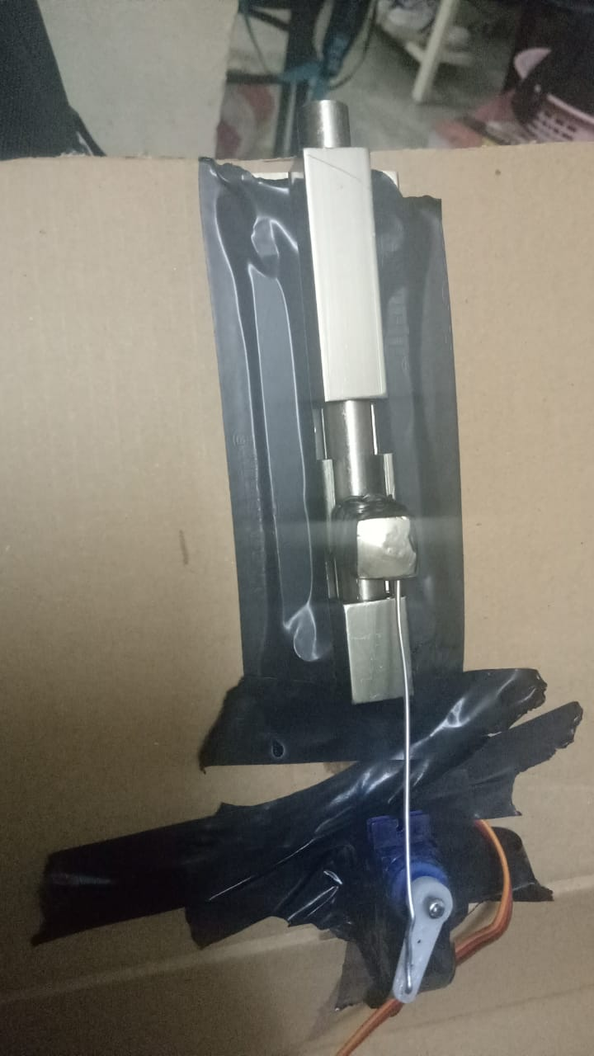

**PROGRAM CODE**

https://github.com/amudgal2000/lab-course/blob/master/programs/Digital%20Bluetooth%20Lock